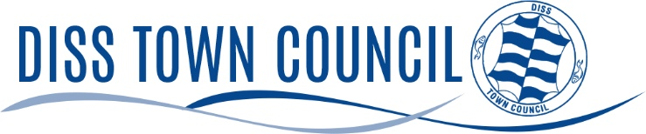

HONOURED CITIZEN REGULATIONS

- The Honoured Citizen Award is a tribute to a member of the community and confers no material honours or special privileges.

- Those qualifying for the Honoured Citizen award should be considered to have undertaken outstanding service to the community.

- Any resident of Diss may be nominated for the award although nominees who do not have residential qualification will be considered at the Town Council’s discretion.

- Nominations should be submitted using the application form to the Town Clerk. The nominee must be proposed and seconded by two Diss residents or those with an interest in the town i.e. business/employment/community group leader or similar. Proposers cannot be a relative of the nominee.

- Serving members of the Town Council are not eligible for the award and are not eligible to propose or second nominations.

- Nominations should be submitted by 12pm on 2nd March 2026.

- The recipient(s) of the award will be decided by Full Council.

- Presentation of the award will be made by the Town Mayor at the Annual Town Meeting on Wednesday 29th April 2026 at The Corn Hall, Diss.

- The recipient(s) will receive a framed certificate and have his/her name inscribed on a Roll of Honour board in the Corn Hall.

- The Council will actively promote this award each year to ensure a good number of nominations are received.

JUNIOR GOOD CITIZEN REGULATIONS

- The Junior Good Citizen award is a tribute to a young person and confers no material honours or special privileges.

- Those qualifying for the Junior Good Citizen award should be considered to have shown good citizenship, outstanding service to the community or individual within it.

- Young people aged 5 – 18 years who either live in Diss or attend school in Diss are eligible.

- Nominations should be submitted using the application form to the Town Clerk. The nominee must be proposed and seconded by two Diss residents or those with an interest in the town i.e. business/employment/community group leader or similar. Proposers cannot be a relative of the nominee.

- Serving Members of the Town Council are not eligible to propose or second nominations.

- Nominations should be submitted by 12pm on 2nd March 2026.

- The recipient(s) of the award will be decided by Full Council.

- Presentation of the award will be made by the Town Mayor at the Annual Town Meeting on Wednesday 29th April 2025 at The Corn Hall, Diss

- The recipient(s) will receive a framed certificate and his/her name will be inscribed on a Roll of Honour board in the Corn Hall.

- The Council will actively promote this award each year in order to ensure a good number of nominations are received.

